**[COMPUTING FUNDAMENTAL]**

**SOLUTION:**

OUTPUT DEVICES

**OUTPUT DEVICES** COMMUNICATE

THE RESULTS OF PROCESSED DATA. 

HEADPHONE

INTERACTIVE BOARD

ROBOT

PROJECTOR

PRINTER

MOTOR

SPEAKER

MONITOR

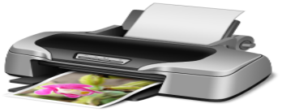

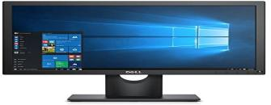

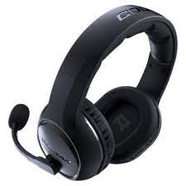

**Can you think of any?**

**OTHER outPUT DEVICES?**

